**ABESEC Ghaziabad**



**Department of Computer Science & Engineering**

**Mini Project REPORT- KCS-354**

**(2019-20)**

|  |  |  |  |  |
| --- | --- | --- | --- | --- |
| **Project Title:**  **UNIT CONVERTER** | | | | |
| **Project Type Application** | |  | | |
|  | **Name** | **Roll Number** | **Section** | **Signature** |
| **Group member** | **Isha Goel** | **1803210067** | **CS-A** |  |
| **Project Guide** | **Mr.Priyansh Singh**  **Mr.Rohit Rastogi** | **Remarks:** | | |
| **Signature** |  |
| **Date**  **of submission** |  |

Contents

* 1. **Problem Introduction………………………………………………….3**

**1.1.1. Motivation………………………………………………………..3**

**1.1.2.Project Objective………………………………………………..3**

**1.1.3.Scope of the project……………………………………………3**

* 1. **Related previous work…………………………………………………4**
  2. **Software and Hardware requirements…………………………6**
  3. **Proposed Method………………………………………………………..7**
  4. **Deliverables……………………………………………………………….11**
  5. **Stakeholders………………………………………………………………20**
  6. **Gantt chart…………………………………………………………………20**
  7. **References………………………………………………………………….21**

# **PROBLEM INTRODUCTION**

* **MOTIVATION**

The main motivation to develop this program is the summer training that was

undertaken under the guidance of college management.

* **PROJECT OBJECTIVE**

Conversion of units is the conversion between different units of measurement for the same quantity through mulitiplicative conversion factors and this program serves the purpose. It would require the user to input the unit he wishes to convert and would convert it into different standard units.

A conversion factor is used to change the units of measured quantity without changing its value.

* **SCOPE OF THE PROJECT**

The program consists of eight different converters as follows:

* LENGTH CONVERTER
* WEIGHT CONVERTER
* VOLUME CONVERTER
* AREA CONVERTER
* CURRENCY CONVERTER
* TIME CONVERTER
* SPEED CONVERTER
* FORCE CONVERTER

Each one of them requires the user to input the magnitude and unit of the desired value he wants to convert and would produce the converted most commonly used standard units.

The input can be either entered through keyboard or through the SPEECH RECOGNITION SYSTEM. The speech recognition system facilitates the user to get the required output merely by using the speech to text feature.The user may also see the search history whenever he requires the previously searched values as it stores all the output along with the input provided by the user.

**Related Previous work**

* **UNIT CONVERTER:** (Smart tools co.)

Unit converter is the 6th set of Smart Tools collection. This app includes Currency (money, bitcoin) exchange rates.

There are a lot of unit conversion apps on the market. However, most are inconvenient and difficult to use because of poor and complicated UI.This app has intuitive and simple UI, that is designed for anybody to use.

There are 4 categories.

- Basic : length (distance), area, weight (mass), volume (capacity)

- Living : exchange rate, temperature, time, speed, shoes, clothing, hat, ring

- Science : pressure, force, work (energy), power, torque, flow, current, voltage, density, viscosity, concentration, astronomy

- Misc. : angle, data, fuel efficiency, cooking, illuminance, radiation, prefix, binary, time zone, blood sugar, hardness, AWG

* **UNIT CONVERTER:** (Digital Grove Tool)

Built-In real time Currency Converter with 150 world currencies and their latest exchange rates

Smart Tools - Bubble Level, Compass, Protractor, Resistor codes, Stop Watch, Ruler, World Time, Date Converter and much more.

New Tools - Battery Monitor, Notes, Expression Evaluation, Equation Solver, Induction Color codes, Scientific Calculator

Financial calculators - Loan calculator, Compound interest calculator, Retirement calculator, Service tax calculator, Stock calculator

Math calculators -Roman numeral converter, Number base converter, Number series generator, Ratio, Fraction, Proportion, etc.

It has most important conversion tools that are used in daily life including Fuel Calculations, Temperature, Volume, Speed, Weight, Computer Storage, Angle, Power, Viscosity, Force, Energy, Torque, Density.

It has conversion tools like radiation, electric resistance, electric capacitance, inductance, inertia, specific heat density, specific heat capacity, and illumination.

* **FULL UNIT CONVERTER:** (Haytham Ayyash Tools)

-It contain many unit conversions and includes the following conversions:

-Distance.

-Area.

-Volume.

-Weight.

-Time.

-Temperature.

-Power.

-Speed.

-Energy.

-Force.

-Pressure.

-Cooking.

-Fuel.

-Digital Storage.

-Number of decimal : you can control of number of decimal .

**HARDWARE REQUIREMENT:**

For this project nothing but a PC is required.

**SOFTWARE REQUIREMENT:**

To begin with this project, a system well versed with Python and Anaconda navigator is required. However any other IDE would also do.

Mine is installed with Python version 3.7.4 and anaconda navigator as it supports Jupyter notebook, it makes the code presentable and increases readability of the code.

It also supports Spyder which is an interactive IDE for python programs.

**IDE USED:**

In developing this project Anaconda(Jupyter Notebook) was used.

Anaconda is a free and open-source distribution of the Python and R programming languages for scientific computing (data science, machine learning applications, large-scale data processing, predictive analytics, etc.), that aims to simplify package management and deployment.

**ANACONDA NAVIGATOR:**

Anaconda Navigator is a desktop graphical user interface (GUI) included in Anaconda distribution that allows users to launch applications and manage conda packages, environments and channels without using command-line commands. Navigator can search for packages on Anaconda Cloud or in a local Anaconda Repository, install them in an environment, run the packages and update them. It is available for Windows, macOS and Linux.

The following applications are available by default in Navigator:

• JupyterLab

• Jupyter Notebook

• QtConsole

• Spyder

• Glueviz and others….

**PROPOSED METHOD:**

**ALGORITHM / APPROACH**

**Step 1:** User is given choices as to which converter he wants to use.

**Step 2:** The choice is input through keyboard and stored in a variable, say ch.

**Step 3:** if ch==1, direct him to the length converter

* Declare lists for different units with their conversion factors and units in them.
* Say meter, list1= [“1000000”,”micrometer”,”100”,”cm”,”0.001”,”km”…].
* Ask the user what magnitude which unit he wants to convert and

store it in a variable, say a.

* Traverse through the list with a for loop and perform calculations with magnitude and conversion factors.
* Display the conversions along with the proper units.

**Step 4:** if ch==2, direct him to the weight converter

* Declare lists for different units with their conversion factors and units in them.
* Say gram, list1= [“1000”,”mg” ,”0.001”,”kg”…].
* Ask the user what magnitude which unit he wants to convert and

store it in a variable, say a.

* Traverse through the list with a for loop and perform calculations with magnitude and conversion factors.
* Display the conversions along with the proper units.

**Step 5:** if ch==3, direct him to the volume converter

* Declare lists for different units with their conversion factors and units in them.
* Say m^3, list1= […].
* Ask the user what magnitude which unit he wants to convert and

store it in a variable, say a.

* Traverse through the list with a for loop and perform calculations with magnitude and conversion factors.
* Display the conversions along with the proper units.

**Step 6:** if ch==4, direct him to the area converter

* Declare lists for different units with their conversion factors and units in them.
* Say m^2, list1= [].
* Ask the user what magnitude which unit he wants to convert and

store it in a variable, say a.

* Traverse through the list with a for loop and perform calculations with magnitude and conversion factors.
* Display the conversions along with the proper units.

**Step 7:** if ch==5, direct him to the currency converter

* Declare lists for different units with their conversion factors and units in them.
* Say INR, list1= […].
* Ask the user what magnitude which unit he wants to convert and

store it in a variable, say a.

* Traverse through the list with a for loop and perform calculations with magnitude and conversion factors.
* Display the conversions along with the proper units.

**Step 8:** if ch==6, direct him to the time converter

* Declare lists for different units with their conversion factors and units in them.
* Say minute, list1= […].
* Ask the user what magnitude which unit he wants to convert and

store it in a variable, say a.

* Traverse through the list with a for loop and perform calculations with magnitude and conversion factors.
* Display the conversions along with the proper units.

**Step 9:** if ch==7, direct him to the speed converter

* Declare lists for different units with their conversion factors and units in them.
* Say m/s, list1= […].
* Ask the user what magnitude which unit he wants to convert and

store it in a variable, say a.

* Traverse through the list with a for loop and perform calculations with magnitude and conversion factors.
* Display the conversions along with the proper units.

**Step 10:** if ch==8, direct him to the force converter

* Declare lists for different units with their conversion factors and units in them.
* Say N, list1= […].
* Ask the user what magnitude which unit he wants to convert and

store it in a variable, say a.

* Traverse through the list with a for loop and perform calculations with magnitude and conversion factors.
* Display the conversions along with the proper units.

**FLOW CHART**

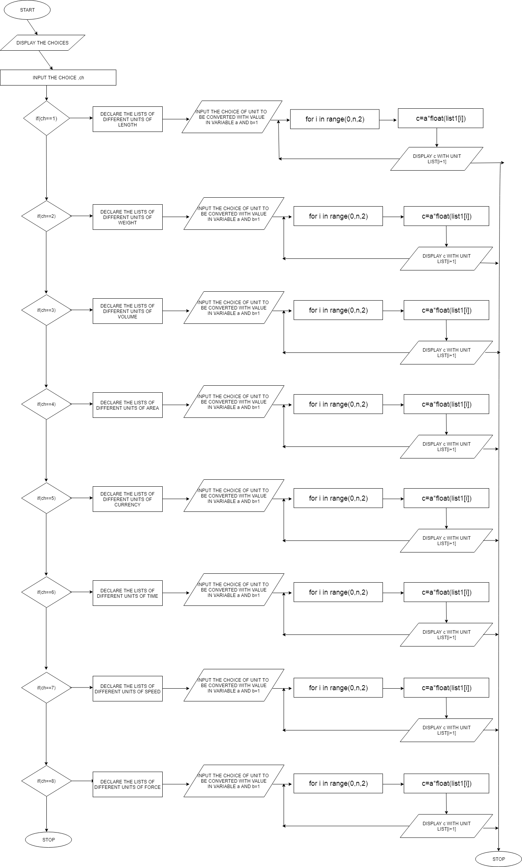

**WORK FLOW DIAGRAM**

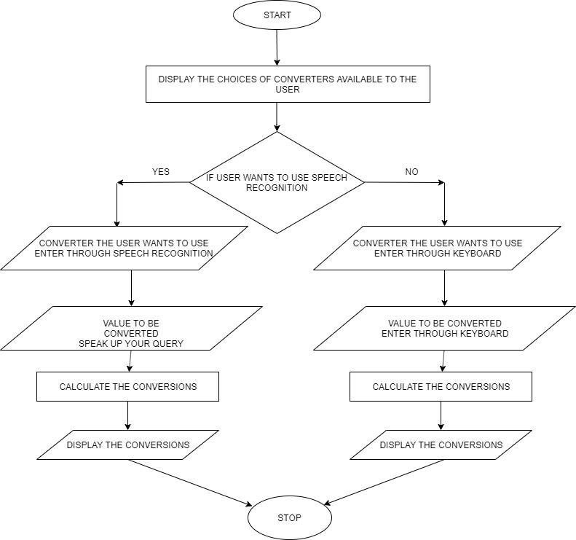

**DELIVERABLES:**

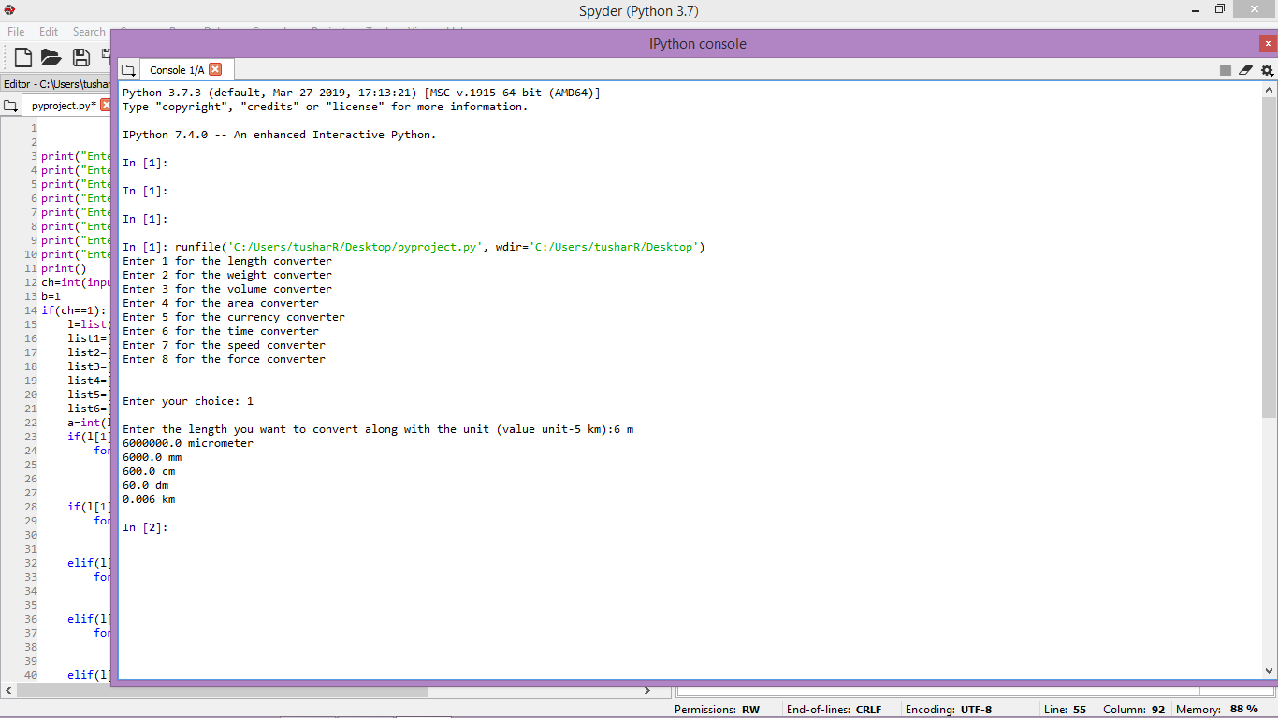

Fig 1. Length Converter

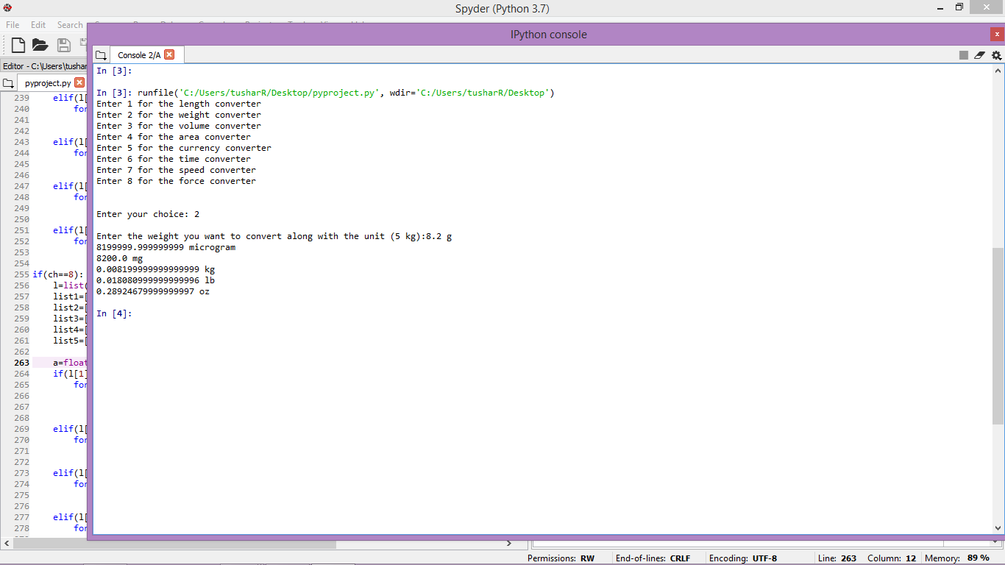

Fig 2. Weight Converter

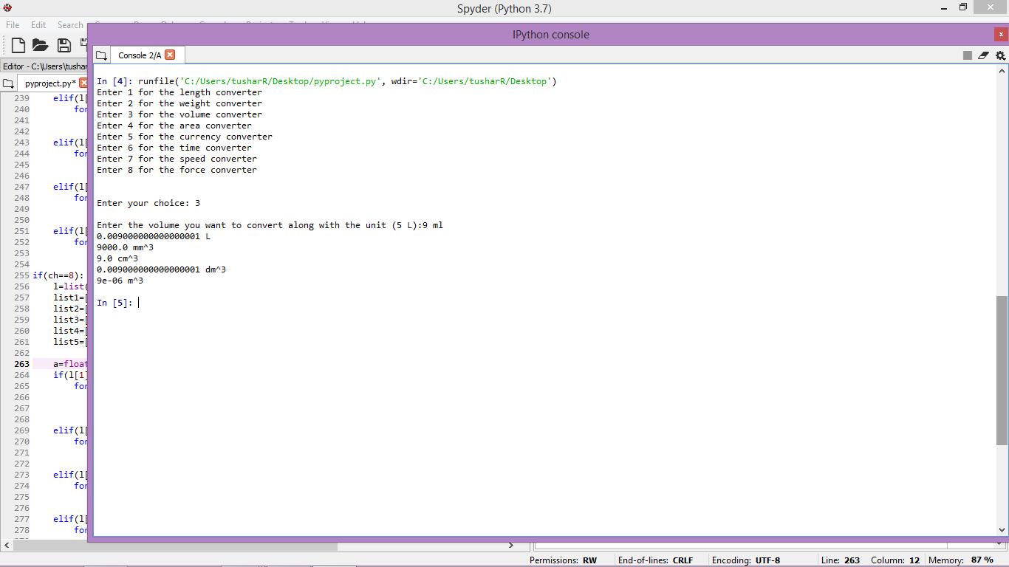

Fig 3.Volume Converter

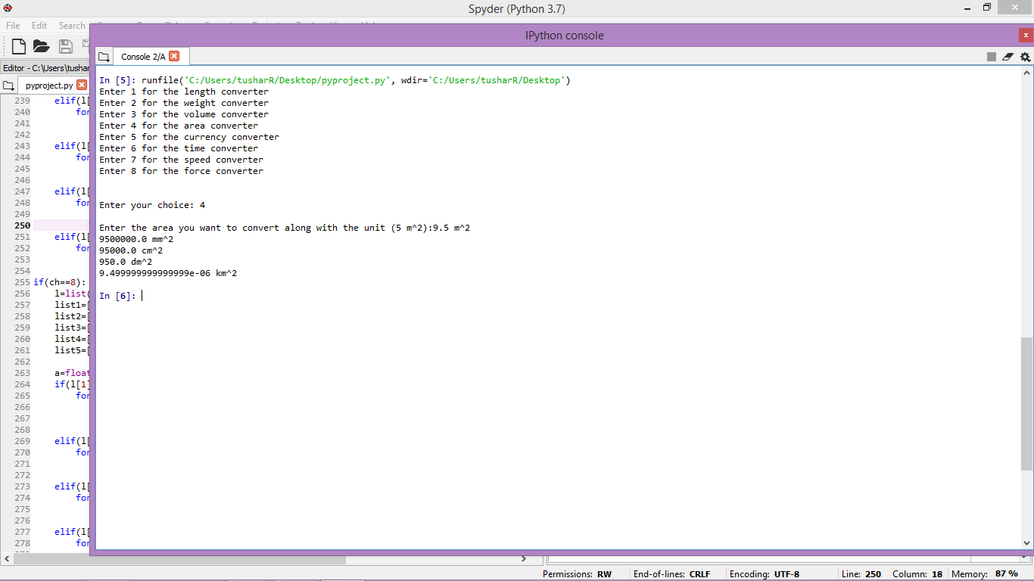

Fig 4. Area Converter

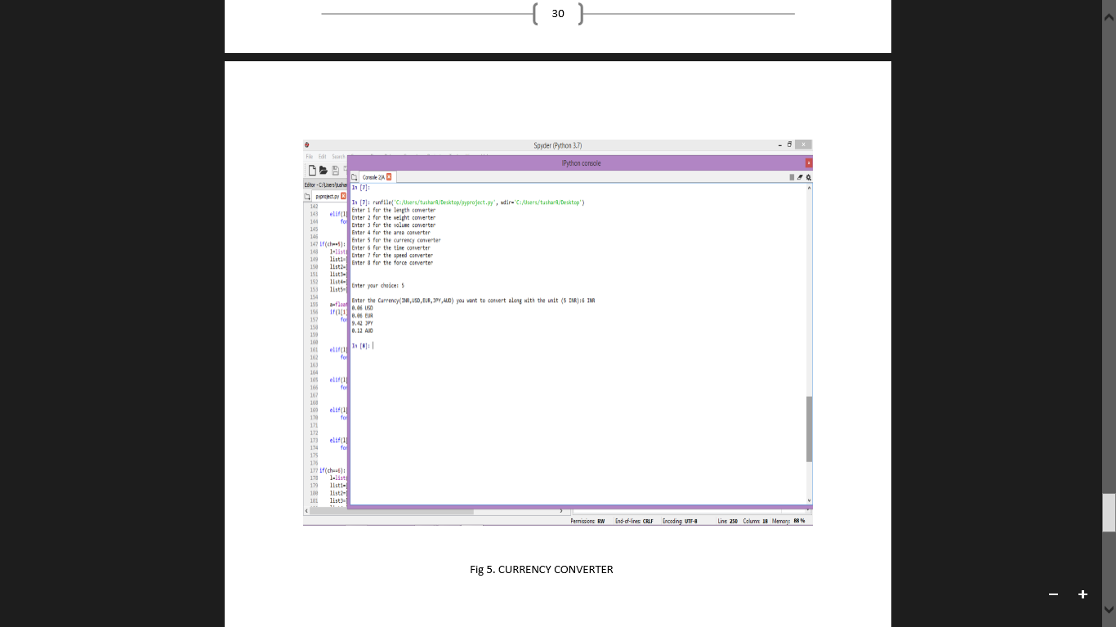

Fig 5. Currency converter

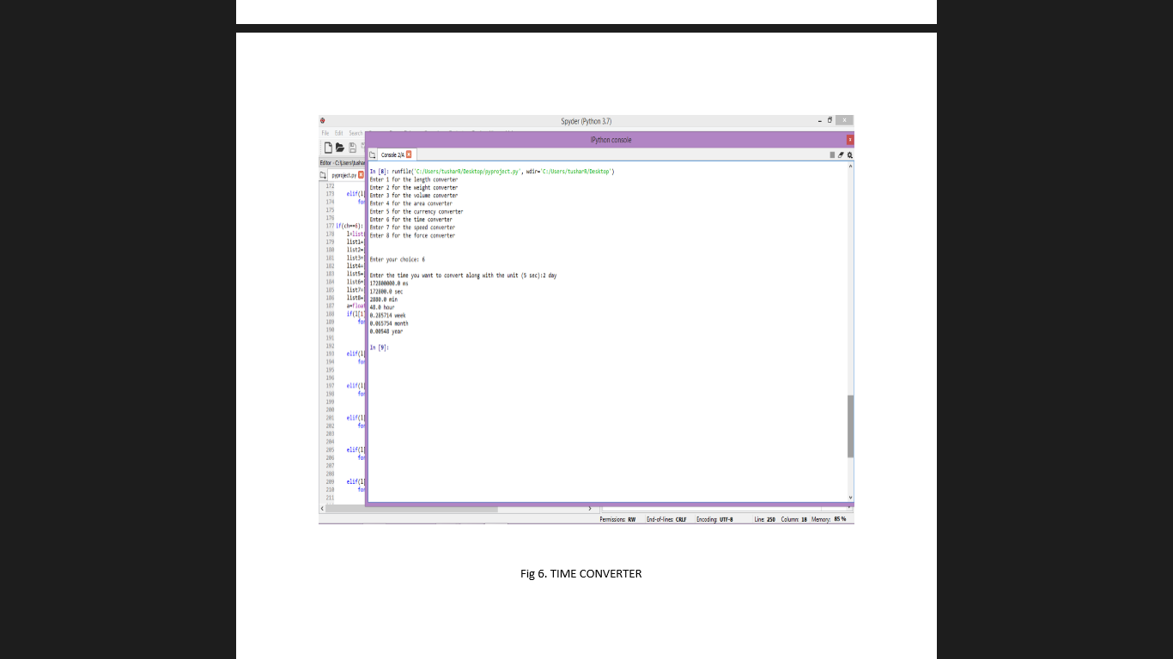

Fig 6.Time Converter

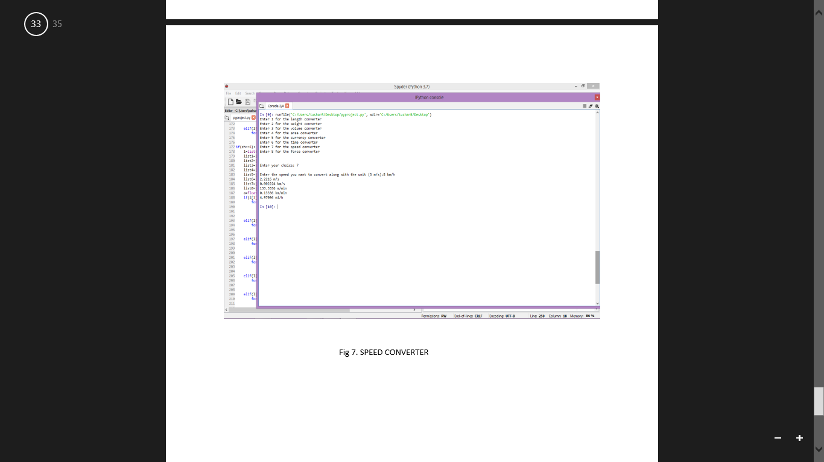

Fig 7.Speed Converter

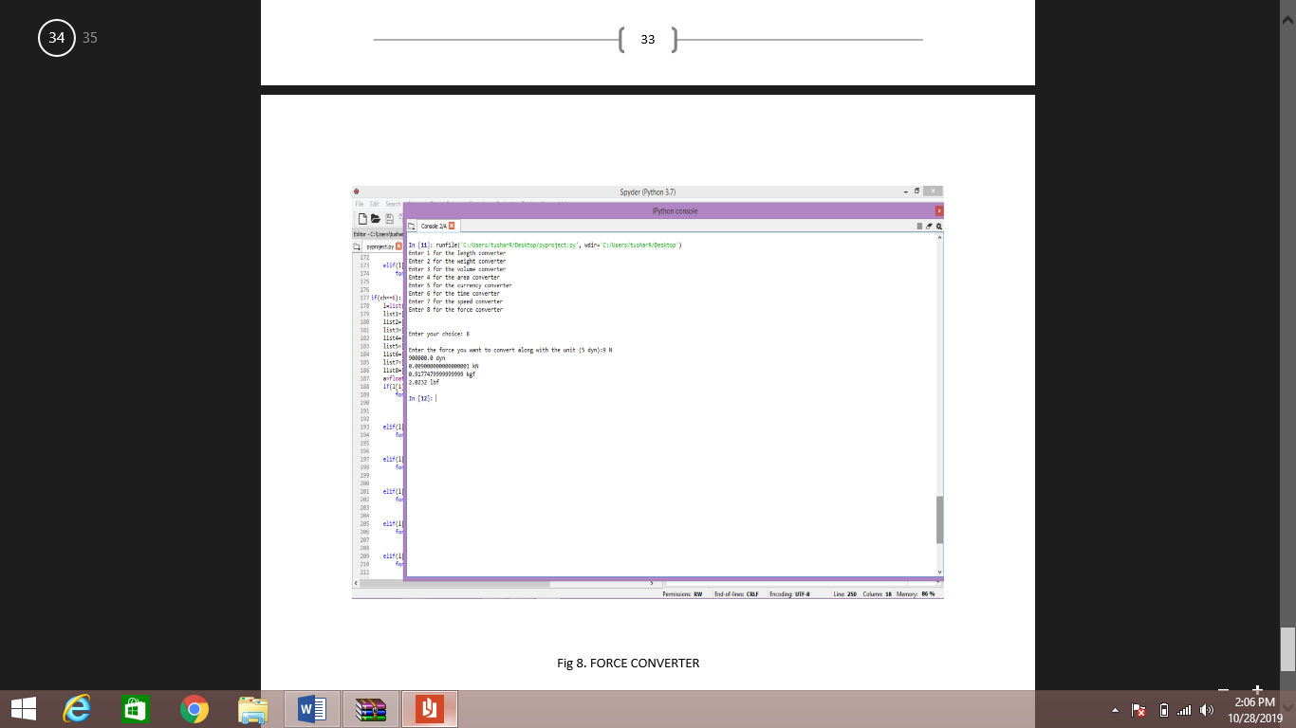

Fig 8. Force Converter

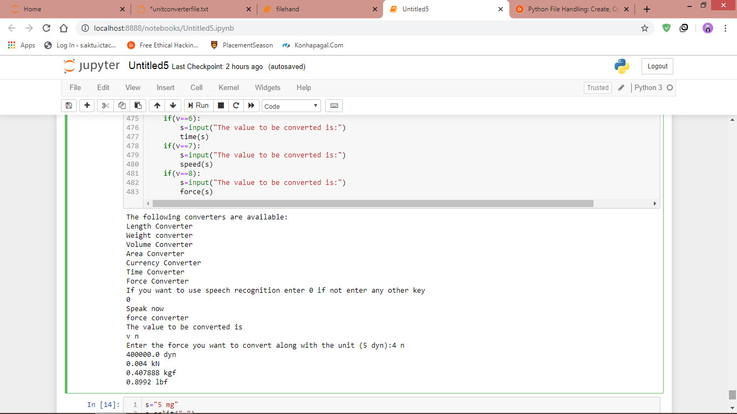

Fig 9. Force Converter with Speech Recognition

**STAKEHOLDERS:**

* Students
* Scientists
* Mathematicians
* Shopkeeper
* Data Analysts
* Physicists
* Foreign currency Exchange
* Investors

**GANTT CHART**

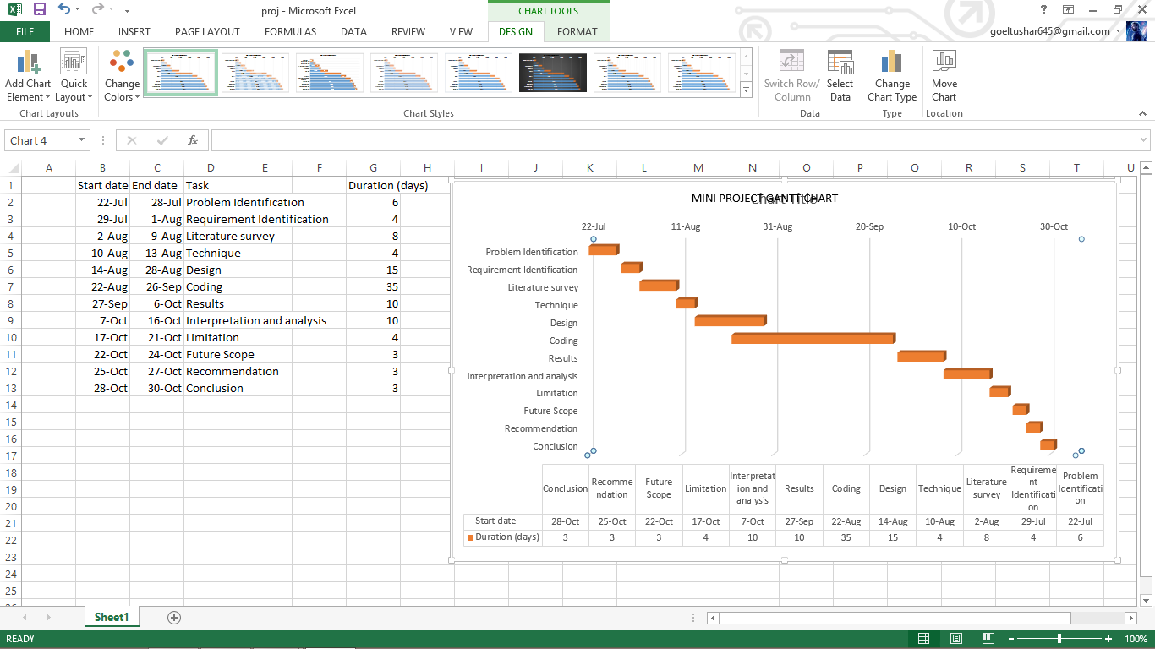

**REFERENCES:**

* <https://www.w3schools.com/>
* <https://www.tutorialspoint.com/>
* <https://stackoverflow.com/>
* <https://www.quora.com/>
* <https://www.geeksforgeeks.org/>